**Mohammad Shafi Bhat**

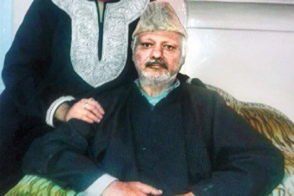

**About:** Senior National Conference leader and former MP Mohammad Shafi Bhat died at his residence here today after prolonged illness, officials said. Bhat was 71 and had been suffering from illness for the past few years. He breathed his last at his Tulsibagh official residence this morning and he was later laid to rest at his ancestral graveyard in Rajbagh locality of uptown Srinagar, the officials said. Also Read - [J&K Constable Killed in Terror Attack on National Conference Leader in Anantnag](https://www.india.com/news/india/jk-constable-killed-in-terror-attack-on-national-conference-leader-in-anantnag-3717083/).

**Murdered on:** 03 OCT -1993

**Attack details :** Senior National Conference leader and former’a news reader radio kashmir.

**Reason to him target :** officials said. Bhat was 71 and had been suffering from illness for the past few years.

**Occupation:** independent candidate after National Conference denied him mandate from Amirakadal. He, however, later withdrew in favour of party candidate Nasir Aslam Wani and returned to the party fold, National Conference sources said. Prior to joining National Conference, Bhat had held various top positions of the High Court Bar Association,

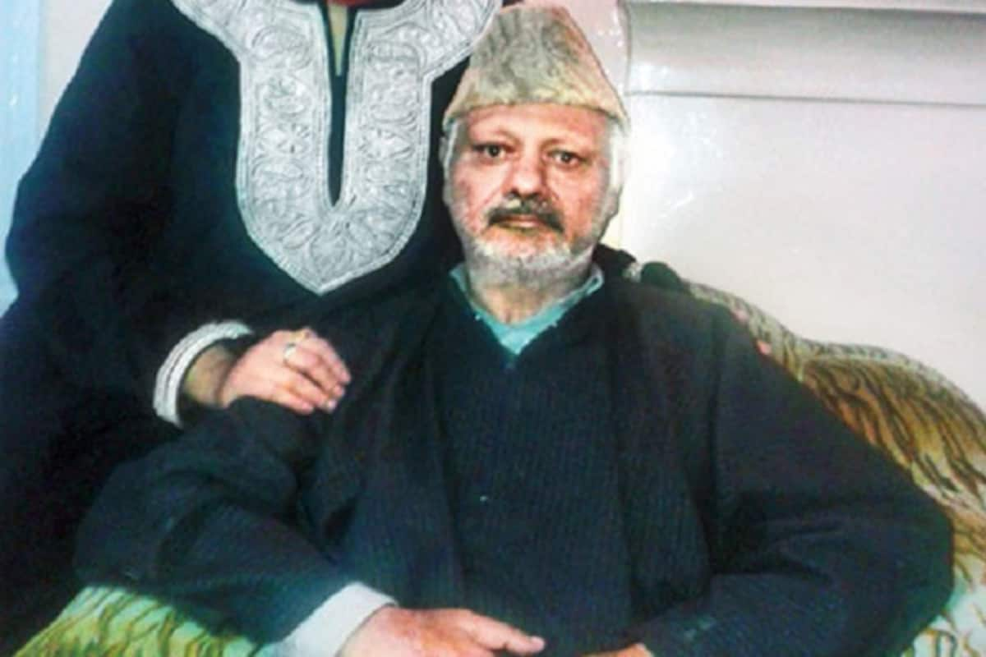**URL** : <https://en.wikipedia.org/wiki/Mohammad_Shafi_Bhat>

<https://bit.ly/36R4O4A>